Ideation Phase
Brainstorm & Idea Prioritization Template

Date | February 2026
Team ID | LTVIP2026TMIDS39049
Project Name | Plugging into the Future: An Exploration of  Electricity Consumption Patterns Using Tableau
Maximum Marks | 4 Marks

Brainstorm & Idea Prioritization Template:
Brainstorming provides a free and open environment that encourages everyone within a team to participate in the creative thinking process that leads to problem solving. Prioritizing volume over value, out-of-the-box ideas are welcome and built upon, and all participants are encouraged to collaborate, helping each other develop a rich amount of creative solutions.
Use this template in your own brainstorming sessions so your team can unleash their imagination and start shaping concepts even if you're not sitting in the same room.
Reference: https://www.mural.co/templates/brainstorm-and-idea-prioritization

Step-1: Team Gathering, Collaboration and Select the Problem Statement
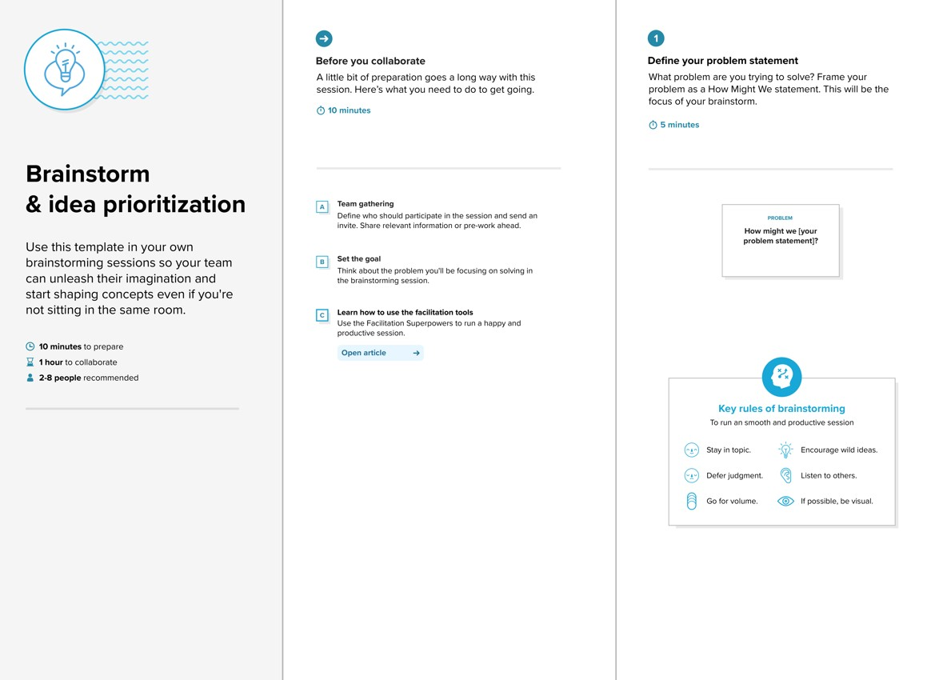

Step-2: Brainstorm, Idea Listing and Grouping
Brainstorm, Idea Listing and Grouping - Build a regional comparison dashboard for electricity usage
- Identify seasonal consumption peaks
- Analyze sector-wise consumption (residential, commercial, industrial)
- Integrate population density data to correlate with energy use - Create time-series graphs for trend analysis
- Add filtering options for dynamic insights
- Use color-coded maps to show consumption intensity
- Link weather and temperature data to electricity spikes
- Compare pre- and post-smart grid implementations
- Predict future consumption using historical data

Step-3: Idea Prioritization
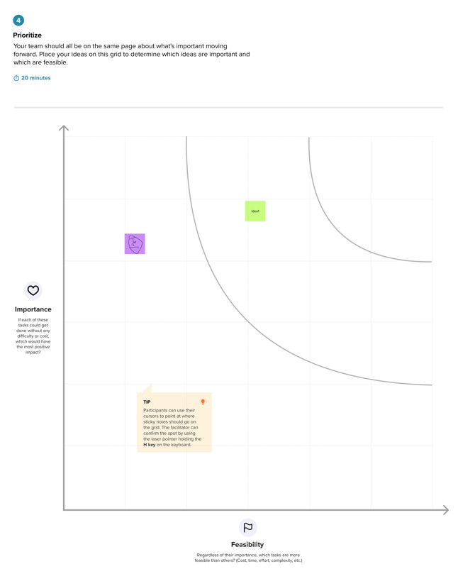

Objective
To explore electricity consumption data through interactive Tableau dashboards and identify:
- Peak consumption periods
- Regional consumption disparities
- Trends over time (e.g., seasonal, yearly)
- Correlation between population/industrialization and electricity use
- Recommendations for energy optimization

